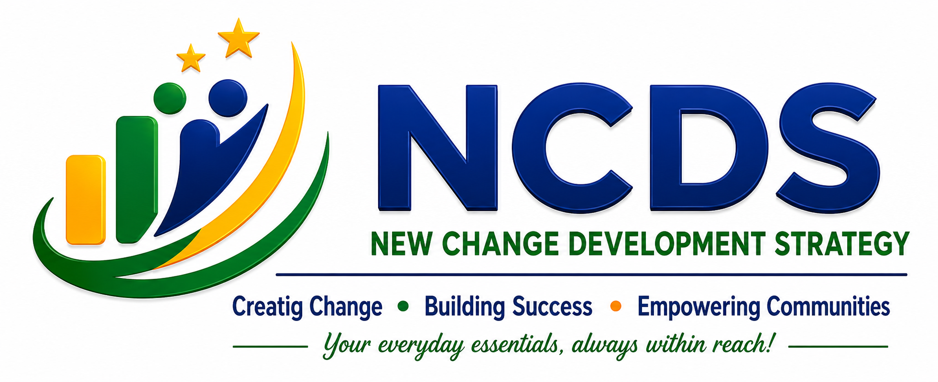

COMPANY PROFILE
New Change Development Strategy

Rwanda | Africa | Global

"We create sustainable development through practical solutions that improve lives and build a better future."
I. COMPANY OVERVIEW

Company Name | New Change Development Strategy (NCDS)
Legal Status | Private Company Limited By Shares
Country | Rwanda, Africa
Region | Kirehe District, Eastern Province
Address | Mahama, Kirehe
Phone | +250 791 532 503
Email | a.ncds.africa@gmail.com
Sector | Multi-Sector Service Provider

II. ABOUT NCDS

New Change Development Strategy (NCDS) is a dynamic, forward-looking private company headquartered in Rwanda, dedicated to providing innovative, professional, and community-focused solutions that contribute to sustainable development across Africa and beyond.

NCDS operates across a diverse range of sectors — from consultancy and digital services to education, financial support, hospitality, and community empowerment — positioning itself as a comprehensive partner for individuals, businesses, and development organizations.

Established in April 2026, NCDS brings a fresh perspective to development challenges, combining local expertise with global best practices. Our goal is to create meaningful opportunities, support economic growth, and promote resilient communities through quality, accessible services.

III. VISION, MISSION & CORE VALUES

🌍 | OUR VISION  To become a leading organization that transforms communities through innovation, entrepreneurship, skills development, and sustainable solutions.

🎯 | OUR MISSION  To provide reliable services and empower people, businesses, and communities through knowledge, technology, and innovative approaches.

Core Values
✦ Integrity Honest and transparent in all operations
✦ Innovation Creative and forward-thinking solutions
✦ Excellence Highest standards in every service
✦ Accountability Responsible to clients and communities
✦ Teamwork Collaborative for collective impact
✦ Community Development Centered on community benefit
✦ Customer Focus Client satisfaction drives all decisions
✦ Sustainability Long-term, lasting positive change

IV. OUR BUSINESS AREAS & SERVICES

1. Consultancy Services
→ Business advice and organizational development
→ Project support, strategic planning, and proposal development
→ Community development solutions and capacity building
→ Policy analysis, program design, and evaluation
→ Baseline, Midline, and Endline Studies
→ Household Surveys and Community Assessments
→ Quantitative and Qualitative Research
→ Key Informant Interviews (KIIs) and Focus Group Discussions (FGDs)
→ Monitoring, Evaluation, Accountability, and Learning (MEAL) Support
→ Market Research and Feasibility Studies
→ Data Collection, Entry, Cleaning, Analysis, and Reporting

Our Strengths
✓ Professional and trained consultants and enumerators
✓ Digital data collection and management systems
✓ Quality assurance and data verification mechanisms
✓ Timely delivery of assignments and reports
✓ Confidentiality, integrity, and ethical standards
✓ Evidence-based recommendations for decision-making

2. Education & Training Services
→ Computer training and digital skills development
→ Professional and academic support services
→ Entrepreneurship development programs
→ Non-formal education support

3. Digital & Office Services
→ Data entry, document preparation and letter writing
→ CV and resume preparation services
→ Printing, photocopying and duplication services
→ Digital support and process automation

4. Business & Entrepreneurship Development
→ Business training and planning support
→ Market guidance and innovation support
→ Small business development programs
→ Business incubation and mentorship

5. Financial & Community Services
→ Money transfer and mobile money agent services
→ Community financial awareness programs
→ Business support initiatives
→ Financial inclusion and accessibility advocacy

6. Hospitality & Service Industry
→ Guesthouse and accommodation services
→ Catering and restaurant activities
→ Beverage services and event support
→ Quality hospitality management

7. Retail & Commercial Services
→ General retail and food & beverage supply
→ Book sales and educational materials
→ Clothing accessories and market-based trading
→ Supply chain and distribution support

V. COMMUNITY IMPACT & SOCIAL RESPONSIBILITY

NCDS is driven by a deep commitment to creating positive, lasting change in the communities we serve. Our impact strategy centers on:

🌱 | Youth Empowerment  Equipping young people with skills, knowledge, and opportunities for a better future.
💻 | Digital Inclusion  Bridging the digital divide by making technology accessible to all community members.
🏢 | Entrepreneurship Support  Nurturing local entrepreneurs to create sustainable businesses and drive economic growth.
🤝 | Capacity Building  Strengthening individual and organizational capabilities for long-term resilience.

VI. PARTNERSHIP OPPORTUNITIES

NCDS actively welcomes collaboration and strategic alliances with national and international partners. We believe sustainable change is best achieved through collective effort. We are open to partnerships with:

- Government institutions and public agencies
- Non-Governmental Organizations (NGOs) and INGOs
- Private companies and corporations
- Training organizations and academic institutions
- Community-based organizations and grassroots groups
- International development partners and funding agencies
- Social enterprises and impact investors

VII. OUR QUALITY COMMITMENT

NCDS is committed to delivering professional services with the highest standards of excellence. Our quality principles include:

✓ Delivering professional, timely, and accurate services
✓ Respecting every client with dignity and cultural sensitivity
✓ Maintaining full transparency in all operations and reporting
✓ Continuously improving our methodologies and approaches
✓ Leveraging innovative and technology-driven solutions
✓ Placing customer satisfaction at the center of all we do

VIII. WHY CHOOSE NCDS?

🌐  Local Expertise, Global Standards  Deep local knowledge combined with internationally recognized practices. | ⚡  Multi-Sector Capacity  One partner for multiple service needs across diverse development sectors. | 💚  Community- Centered Mission  Every service is designed with community benefit and inclusion in mind.

IX. ADMINISTRATION METHOD

NCDS operates under a professional and transparent management system designed to ensure accountability, efficiency, and sustainable growth.

Governance Structure
→ Managing Director – Provides strategic leadership and overall company direction; oversees operations, partnerships, and organizational development; ensures compliance with legal and regulatory requirements.
→ Administration and Operations – Coordinates daily business activities; manages records, communication, and organizational resources; supports effective implementation of company programs and services.
→ Finance and Compliance – Maintains financial accountability and reporting; oversees budgeting, resource allocation, and financial planning; ensures adherence to company policies and legal obligations.
→ Programs and Service Delivery – Plans, implements, and monitors projects and services; ensures quality standards and customer satisfaction; coordinates stakeholder engagement and partnership activities.

Management Approach
- Transparency in decision-making and reporting
- Accountability at all levels of operation
- Participatory leadership and teamwork
- Customer-centered service delivery
- Continuous learning and innovation
- Efficient resource management
- Monitoring, evaluation, and quality improvement

Decision-Making Process
NCDS promotes collaborative decision-making where management, staff, partners, and stakeholders contribute to organizational growth. Major strategic decisions are approved by company leadership, while operational decisions are delegated to responsible departments for efficient implementation.

X. MONITORING, EVALUATION, ACCOUNTABILITY AND LEARNING (MEAL)

At NCDS, we recognize that sustainable impact requires effective monitoring, transparency, accountability, and continuous learning. We apply a MEAL framework across all our programs and services.

Monitoring  Regular tracking of activities and performance indicators. Accurate data collection to measure progress. | Evaluation  Periodic assessment of effectiveness, efficiency, impact, and sustainability for evidence-based decisions. | Accountability  Transparency to beneficiaries, partners, and stakeholders. Feedback and complaint-response mechanisms. | Learning  Documenting lessons learned and best practices. Applying knowledge to improve future interventions.

XI. CONTACT INFORMATION

NEW CHANGE DEVELOPMENT STRATEGY (NCDS)
Creating Change • Building Success • Empowering Communities
📍 Mahama, Kirehe District, Eastern Province, Rwanda
📞 +250 783 308 710
📱 WhatsApp: +250 791 532 503
✉ a.ncds.africa@gmail.com
🌐 ncds.com

XII. COMPANY PROFILE APPROVAL

This Company Profile of New Change Development Strategy (NCDS) has been reviewed, verified, and approved as an official representation of the company's vision, mission, services, and operational activities.

The information contained herein is accurate to the best of our knowledge and is authorized for use in business engagements, partnership development, marketing, stakeholder communication, and organizational representation.

I hereby certify that this Company Profile is approved for official use and represents the strategic direction and operational scope of New Change Development Strategy (NCDS).

Authorized Signature  Managing Director, NCDS | Official Stamp / Date  April 2026

"Creating Change • Building Success • Empowering Communities"
Copyright © 2026 NCDS. All Rights Reserved.

